Secure Application Programming
Project

Student Name: Moses Ademokun
Student Number: x20126204
Module: Secure Application Programming
Date:20th Dec 2025

Revisions

Version | Primary Author | Description of Version | Date Completed
V1.0 | Moses Ademokun | First Draft | 20/12/2025

Table of Contents

Table of Contents
Software Development Lifecycle Methodology 2
Introduction 2
Software Requirement Specification: 3
General Description: 3
Requirements : 3
Functional Requirements: 3
Non-Functional Requirements: 3
Data Classification: 4
Entity Relation Diagram (ERD): 4
Technical Specification: 5
High-Level Architectural Diagram 5
Wireframes: 5
Use-Case Diagram: 7
Use-Case Description: 8
Class Diagram: 12
Sequence Diagram: 12
Testing Plan 13
Discussion on the Insecure Code: 13
Discussion on the Secure Code: 13
Ethics Question: 13
Appendix A Breakdown of Marks 14
Appendix B 14

Software Development Lifecycle Methodology
Models Compared: Agile vs. Iterative

Agile Model:
- Focuses on flexibility, collaboration, and iterative development.
- Frequent feedback and adaptation to change.
- Supports continuous integration, testing, and secure coding practices.
- Ideal for projects with evolving requirements and security needs.

Iterative Model:
- Develops the application in repeated cycles (iterations).
- Each cycle adds features and refines the product.
- Good for gradually introducing and fixing vulnerabilities.
- Allows for incremental improvement and testing.

Justification:
Agile is chosen for this project because it enables rapid response to feedback, supports secure coding practices, and allows for continuous testing and improvement. This aligns with the project’s requirements for secure/insecure code comparison, thorough testing, and ethical review.

Introduction

In this project, an open-source web application is developed using Node.js with Express for the backend and React for the frontend. The database is SQLite3. The application demonstrates both vulnerable (insecure) and secure coding practices, focusing on SQL Injection, XSS, and Sensitive Data Exposure. Two implementations are provided: an insecure version (with vulnerabilities) and a secure version (with mitigations and security features).

Software Requirement Specification:

General Description:
This project is a simple blog platform web application. Users can register, log in, and create, edit, or delete their own blog posts. The application is designed to demonstrate both insecure and secure coding practices, specifically focusing on SQL Injection, Cross-Site Scripting (XSS), and Sensitive Data Exposure vulnerabilities. There are two main versions: an insecure version (with vulnerabilities intentionally left in) and a secure version (with mitigations and best practices applied).

Write a short paragraph describing the web application that you will build.

Describe how you can incorporate Secure Application Principles into the project.
- Principle of Least Privilege
- Principle of Secure Defaults
- Principle of Fail Securely
- Principle of Separation of Duties
- Principle of Defense in Dept

Requirements :
Product Scope:
- The application allows users to create an account, log in, and manage their own blog posts.
- Users can create, view, edit, and delete blog posts.
- The insecure version demonstrates vulnerabilities (SQL Injection, XSS, Sensitive Data Exposure).
- The secure version mitigates these vulnerabilities and adds security features (CSRF protection, session management, security headers, logging, and monitoring).
- The application does not include advanced features such as comments, media uploads, or user roles beyond basic authentication.
- The UI is kept simple to focus on secure programming concepts rather than design or UX.

Functional Requirements:
- User authentication (login/register)
- Create, edit, and delete blog posts
- Demonstrate vulnerabilities (SQL Injection, XSS, Sensitive Data Exposure)
- Secure versions of all features
- Logging and monitoring

Non-Functional Requirements:
- Usability: Intuitive UI, clear error messages
- Performance: Responsive interface, efficient queries
- Security: OWASP Top 10 compliance, secure coding standards
- Reliability: Error handling, data validation

Data Classification:
| Type of Data | Basis for Collection | Security Features (Secure Version) |
|------------------------------|-------------------------------------|----------------------------------------------|
| Username, Password | User authentication and access | Passwords hashed (bcrypt), HTTPS, input validation |
| Blog Post Content, Title | User-generated content | Input validation, output encoding, XSS protection |
| Session Token (JWT) | Session management | Secure token storage, HTTP-only cookies, CSRF protection |
| Logs (login, actions, errors)| Monitoring and auditing | Access controls, log sanitization, monitoring |

Sensitive data (e.g., passwords) is never stored in plaintext. The application is designed to comply with data protection principles such as the GDPR, ensuring users can request deletion of their data. Only minimal personal data is collected, and all sensitive operations are protected in the secure version.

Diagram (ERD):
Consider the type of data required to build your web application and create an ERD diagram.
What information is required for a user to log in Name, Email, Password are you incorporating a security principle that allows a user so many attempts before being logged out are you separating the content of your site depending on the age of the user. What would the table look like if it was displaying blog posts or a TO-DO list?

Tip this is not a real website that you are building this is an exercise in how to create an insecure and a secure web application that has a SQL injection, a stored XSS vulnerability and needs to incorporate elements of session management so think of the database in terms of how best to achieve this. Think of the security principles and how these can best be incorporated into your project will you use a hash for the user password will you be using different hashing algorithm? will you be using a database for proper logging of your application what would that table look like?
*Insert ERD diagram and explanation here.*

Technical Specification:
A short paragraph introducing the technical aspects of your project.

High-Level Architectural Diagram
Provide a high-level architectural diagram of the application describing the technologies that you intent to use. Node or PHP.

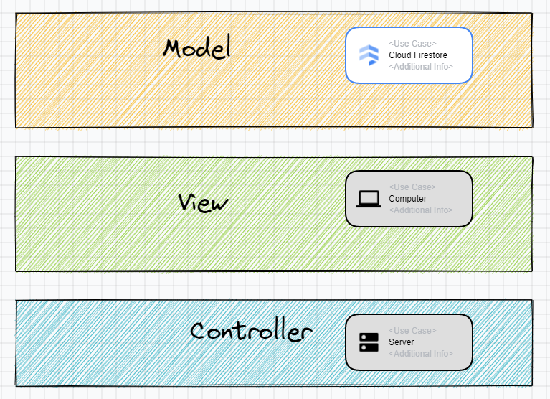

Provide a short paragraph describing this diagram.

Wireframes:
Provide a wireframe of each page in your application this will help you when you come to fill out your Use-Case Description.



Page 1

Page 2

Page 3

Use-Case Diagram:
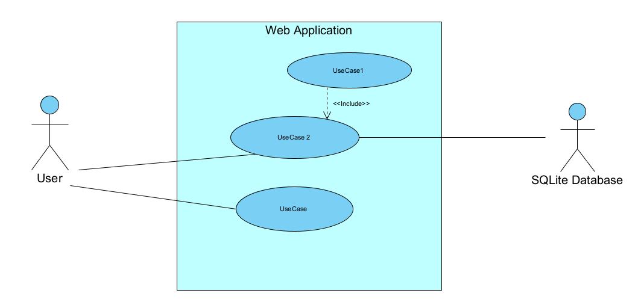
Keep use-case diagrams simple the important things to remember.
- Use-Cases are described from the perspective of the main user.
- What’s inside the system box is under your control.
- Use-case name Verb Noun if the most important aspect of this UML it should be obvious to the reader what is its function.
- For every use-case in the use-case diagram there must be a use-case description. DO NOT include ovals in this diagram that parr of the use case description this is a high-level overview of the system.
- The Use-Case name must match in the use case description.
- Includes Use-Case is part of the DRY Don’t repeat yourself principle and they must always be called.
- If you find yourself with too many use-cases in the diagram you are defeating the purpose of the diagram. As a rule of thumb keep the number of use-cases to around seven if your system requires more consider splitting into more than one use-case diagram.

Use-case | Use-Case Name | Description
UC-1
UC-2
UC-3
UC-4

Use-Case Description:
Provide a brief description of each use case remember the use-case names must match the name in the use case diagram.

Use Case ID:
Use Case Name:
Created By: |  | Last Updated By:
Date Created |  | Last Updated Date
Description:

Actors:
Primary
Secondary

Triggers:

Pre-conditions:

Post-Conditions:

Normal Flow:

Alternate Flows:

Exceptions:

Includes:

Extends:

Priority:

Special Conditions:

Assumptions:

Notes and Issues:

Use Case ID:
Use Case Name:
Created By: |  | Last Updated By:
Date Created |  | Last Updated Date
Description:

Actors:
Primary
Secondary

Triggers:

Pre-conditions:

Post-Conditions:

Normal Flow:

Alternate Flows:

Exceptions:

Includes:

Extends:

Priority:

Special Conditions:

Assumptions:

Notes and Issues:

Use Case ID:
Use Case Name:
Created By: |  | Last Updated By:
Date Created |  | Last Updated Date
Description:

Actors:
Primary
Secondary

Triggers:

Pre-conditions:

Post-Conditions:

Normal Flow:

Alternate Flows:

Exceptions:

Includes:

Extends:

Priority:

Special Conditions:

Assumptions:

Notes and Issues:

Use Case ID:
Use Case Name:
Created By: |  | Last Updated By:
Date Created |  | Last Updated Date
Description:

Actors:
Primary
Secondary

Triggers:

Pre-conditions:

Post-Conditions:

Normal Flow:

Alternate Flows:

Exceptions:

Includes:

Extends:

Priority:

Special Conditions:

Assumptions:

Notes and Issues:

Class Diagram:
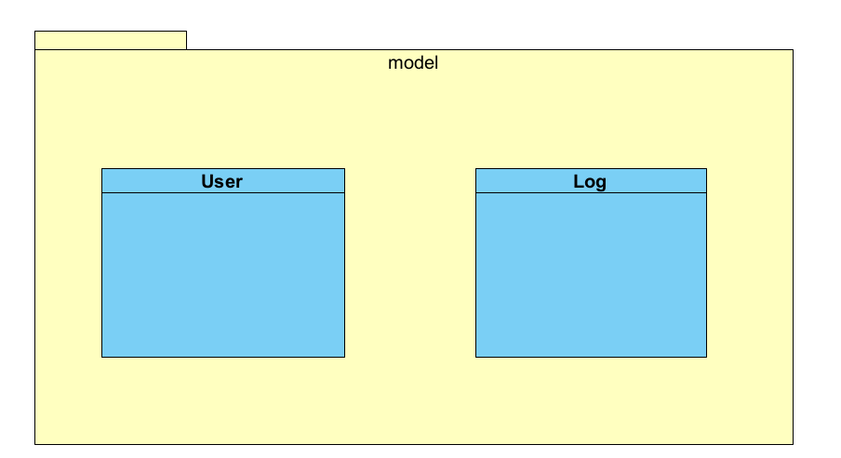
Demonstrate you understanding of Design patterns by incorporating a few of them for example Singlton or Observer patterns. In your code use The Don’t Repeat Yourself (DRY) and Solid principles. Explaining how you used the in code.

Sequence Diagram:

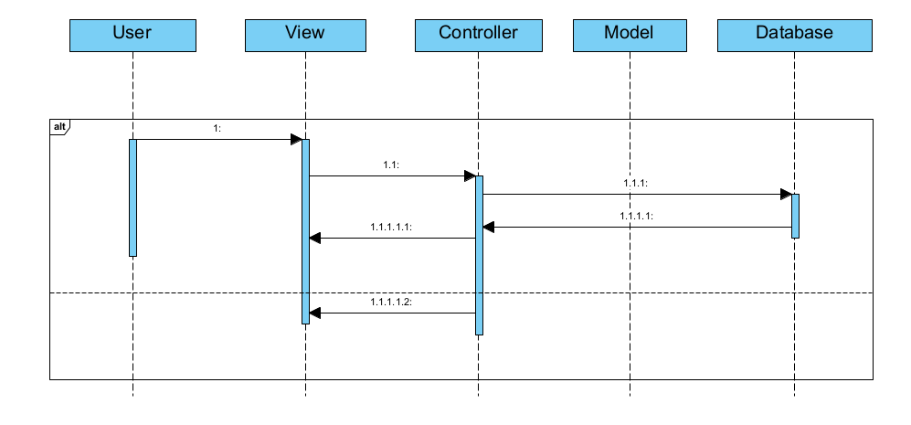
Describe the sequence of messages outlined in the sequence diagram.

Testing Plan
Create a testing plan is based on the normal, Alternate and Exceptional flows in each Use Case Description.

Provide details of the results of this plan.

Use Selenium or Playwright to create tests of your application.

Test the Non-Function requirements of your App using the Chrome developer tools.

Carry out DAST testing on both the Secure and Insecure Branches of your Code using ZAP.
Highlight any Vulnerabilities raised by the tool.

Discussion on the Insecure Code:
Explain the following vulnerabilities and illustrate how you implemented them in your application. Reference the OWASP Top 10 in your answer.
- SQL Injection.
- XSS.
- Sensitive Data Exposure.

Why are they so dangerous?
How a hacker could exploit these vulnerabilities
Provide screen shots of the code.
Provide a screen shot of these vulnerabilities in action in your application.

This section presents the **insecure implementation** first, with code snippets and explanations for each vulnerability. Only one version (insecure or secure) should be active in the codebase at a time.

### SQL Injection (Insecure Example)
```js
// Vulnerable: direct string interpolation, no user_id
app.post('/posts', (req, res) => {
const { title, content } = req.body;
if (!title || !content) return res.status(400).json({ error: 'Missing fields' });
const sql = `INSERT INTO posts (title, content) VALUES ('${title}', '${content}')`;
db.run(sql, function(err) {
if (err) return res.status(400).json({ error: err.message });
res.json({ id: this.lastID, title, content });
});
});
```
**Explanation:** This endpoint is vulnerable to SQL Injection because user input is directly interpolated into the SQL query string without sanitization or parameterization.

### Cross-Site Scripting (XSS) (Insecure Example)
```js
// Insecure: Get all posts (no output encoding, XSS possible, no auth)
app.get('/posts', (req, res) => {
db.all('SELECT * FROM posts', [], (err, rows) => {
if (err) return res.status(500).json({ error: err.message });
res.json(rows);
});
});
```
**Explanation:** No output encoding or sanitization is performed, so malicious scripts in post content can be executed in the browser.

### Sensitive Data Exposure (Insecure Example)
```js
// Insecure: Passwords stored in plaintext (if not using bcrypt)
// Example (not recommended):
db.run('INSERT INTO users (username, password) VALUES (?, ?)', [username, password]);
```
**Explanation:** Storing passwords in plaintext exposes users to credential theft if the database is compromised.

**References:**
- [OWASP Top 10](https://owasp.org/www-project-top-ten/)

---

Discussion on the Secure Code:
Explain how you secured your application from the SQL injection XSS vulnerability and how use mitigated the Sensitive Data Exposure. Reference the OWASP Cheat sheets as to the available options to secure the application.

Discuss how you incorporated proper logging and monitoring. Make a reference to the
What security headers were added and explain why they improved the security.

This section presents the **secure implementation** after the insecure code, with code snippets and explanations for each mitigation. Only one version (insecure or secure) should be active in the codebase at a time.

### SQL Injection Mitigation (Secure Example)
```js
// Secure: Use parameterized queries and authentication
app.post('/posts', authenticateToken, (req, res) => {
const { title, content } = req.body;
const userId = req.user.id;
if (!title || !content) return res.status(400).json({ error: 'Missing fields' });
db.run('INSERT INTO posts (title, content, user_id) VALUES (?, ?, ?)', [title, content, userId], function(err) {
if (err) return res.status(400).json({ error: err.message });
res.json({ id: this.lastID, title, content });
});
});
```
**Explanation:** This endpoint uses parameterized queries to prevent SQL Injection and requires authentication.

### XSS Mitigation (Secure Example)
```js
// Secure: Output encoding and input validation (frontend and backend)
// Example: Use libraries like DOMPurify on the frontend, and validate/sanitize input on the backend.
```
**Explanation:** Output encoding and input validation prevent malicious scripts from being executed.

### Sensitive Data Protection (Secure Example)
```js
// Secure: Passwords hashed with bcrypt
const hashedPassword = bcrypt.hashSync(password, 10);
db.run('INSERT INTO users (username, password) VALUES (?, ?)', [username, hashedPassword]);
```
**Explanation:** Passwords are hashed before storage, protecting user credentials.

**Additional Mitigations:**
- Security headers (Helmet)
- CSRF protection
- Session management (JWT, HTTP-only cookies)
- Logging and monitoring

**References:**
- [OWASP Cheat Sheet Series](https://cheatsheetseries.owasp.org/)

Ethics Question:
You are working as a contractor in a large software development company you like the work and the organisation and any future work will depend on how you get on with the lead developer. During the final stage of the project, you are tasked with alpha testing and performing a code review where you discover a major vulnerability that would seriously affect the confidentiality integrity and availability of sensitive data held by the organisation. This discovery was only possible because of a penetration test that you had performed for a different client but as part of that test, you signed a letter of engagement which included a non-disclosure clause. You advised the lead developer of your findings and because of a lack of time to fix that problem, he does not want to do anything about it.
Consider three of the Software Engineering Code of Ethics principles and describe what you are going to do about the ethical issues raised by this scenario.

Answer

Appendix A Breakdown of Marks
Section | Description | % mark
1 | Software Development Lifecycle justification | 10%
2 | Software Requirement Specification | 20%
3 | The Use of GitHub for code and project planning | 5%
4 | Discussion of Insecure code implementation | 20%
5 | Discussion of Secure code implementation | 20%
6 | Testing Documentation and results | 10%
7 | Short video demonstrating your project | 5%
8 | Ethics | 10%

Appendix B
Link to GitHub:

Link to Video Demonstration:

